

Search

[Write](https://medium.com/new-story?source=post_page---top_nav_layout_nav-----------------------------------------)



[Home](https://medium.com/?source=post_page--------------------------------------------)

[Library](https://medium.com/me/lists?source=post_page--------------------------------------------)

[Profile](https://medium.com/@dk1078451?source=post_page--------------------------------------------)

[Stories](https://medium.com/me/stories/drafts?source=post_page--------------------------------------------)

[Stats](https://medium.com/me/stats?source=post_page--------------------------------------------)

Get unlimited access to the best of Medium for less than $1/week.

[Become a member](https://medium.com/plans?source=upgrade_membership---post_top_nav_upsell-----------------------------------------)

Deepanshu



**How to Deploy the K8s Voting App on AWS EC2 with Kind and ArgoCD**

[[](https://medium.com/@mudasirhaji?source=post_page---byline--04c7b92e24b4---------------------------------------)](https://medium.com/@mudasirhaji?source=post_page---byline--04c7b92e24b4---------------------------------------)

[Mudasir](https://medium.com/@mudasirhaji?source=post_page---byline--04c7b92e24b4---------------------------------------)

·

Following

11 min read

·

Sep 15, 2024

10

1

In this blog post, we will walk through the steps to deploy the Voting App, based on the [k8s-kind-voting-app](https://github.com/LondheShubham153/k8s-kind-voting-app/) GitHub project, on an AWS EC2 instance. Before we dive into the technical details, let’s briefly discuss Kubernetes and Kind, the tool we will use to run Kubernetes clusters locally.

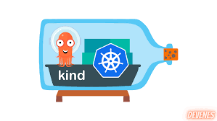

**What is Kubernetes and kind?**

Kubernetes (often abbreviated as K8s) is an open-source platform for automating containerized applications' deployment, scaling, and management. It is highly scalable and widely adopted by organizations for managing container workloads.

However, setting up a Kubernetes cluster can be complex, especially for local development or testing purposes. This is where **kind** (Kubernetes in Docker) comes into play. **kind** allows you to run Kubernetes clusters inside Docker containers. It is lightweight, fast to set up, and ideal for local development and testing. You can simulate a full-fledged cluster by running Kubernetes in Docker without needing dedicated hardware or cloud resources.

**Prerequisites**

Before starting, ensure you have the following:

* An AWS account.
* Basic familiarity with Linux and Docker containers

Now, let’s begin with the step-by-step deployment process!

**Step 1: Create an Ubuntu EC2 Instance**

**1.1. Launch a New EC2 Instance**

1. Log in to your [AWS Management Console](https://aws.amazon.com/console/).
2. Navigate to **EC2** from the AWS services list and click **Launch Instance**.
3. Enter a name for your instance and select **Ubuntu Server 22.04 LTS** as your Amazon Machine Image (AMI).

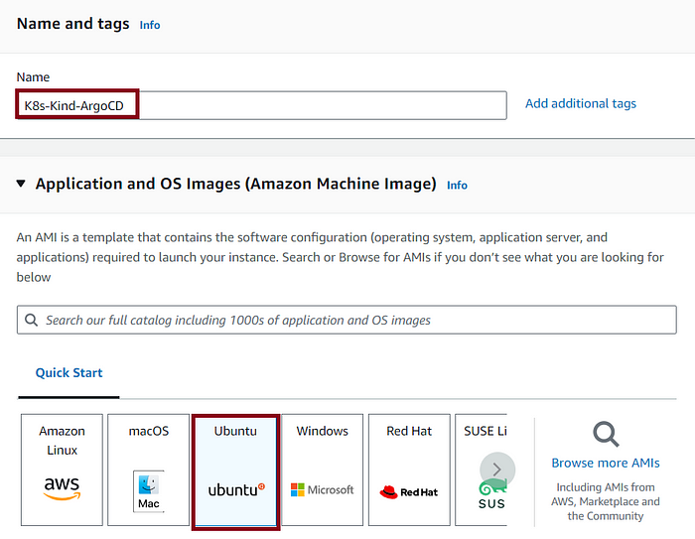

4. Select an instance type. We recommend using at least t2.medium (2 CPUs, 4GB RAM) for a smoother experience.

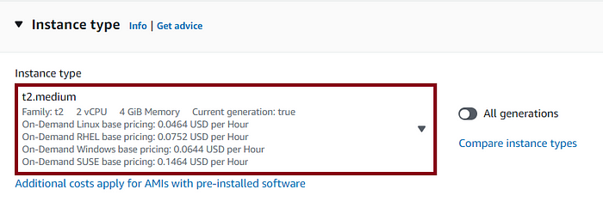

5. In **Key Pair**, select an existing key pair or create a new one. This key is essential for SSH access to the EC2 instance.

6. Configure **Network Settings**. You can use the default VPC and set **Allow SSH traffic from** to your IP or from anywhere (0.0.0.0/0) for ease of access.  
Also, select Allow HTTPS and HTTP traffic from the internet.

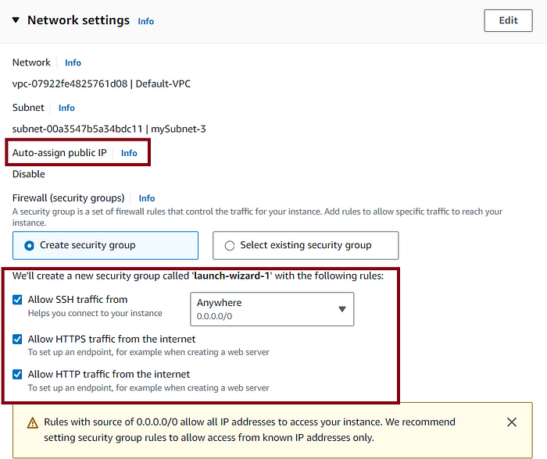

7. Under **Storage**, choose 15GB as the storage size instead of the default 8GB.

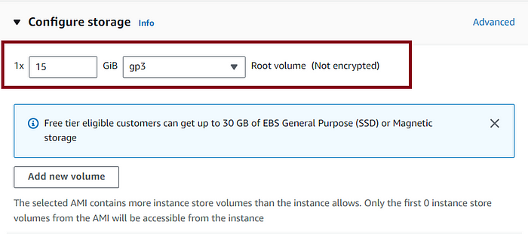

8. Click **Launch Instance** to create the EC2 instance.

**1.2. Connect to Your EC2 Instance**

Once your instance is running, connect to it via SSH:

1. From the **EC2 Dashboard**, select your instance and click **Connect**.
2. Follow the instructions for **SSH client**:

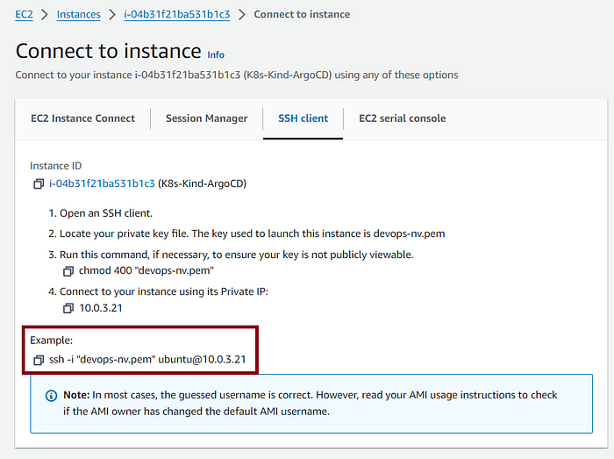

**Step 2: Install Docker on the EC2 Instance**

We’ll need Docker to run both **kind** and the containers for our Kubernetes cluster.

**2.1. Update the Package List**

First, ensure your package list is up to date:

sudo apt-get update

**2.2. Install Docker**

Now, install Docker with the following commands:

sudo apt-get install docker.io -y

**2.3. Start and Enable Docker**

Start the Docker service and ensure it runs on boot:

sudo systemctl start docker  
sudo systemctl enable docker

**2.4. Verify Docker Installation**

To verify that Docker is installed and running correctly, run:

sudo docker --version  
sudo systemctl status docker

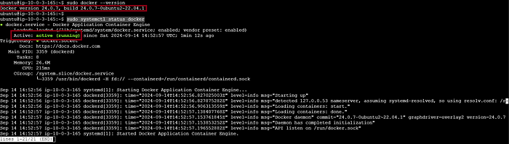

Note: To add the current user in the docker group we should issue the below command to avoid using sudo every time we use docker commands.

sudo usermod -aG docker $USER && newgrp docker

**Step 3: Install kind and kubectl**

**3.1. Install kind**

Download and install **kind**:

curl -Lo ./kind https://kind.sigs.k8s.io/dl/v0.20.0/kind-linux-amd64  
chmod +x ./kind  
sudo mv ./kind /usr/local/bin/kind

the output would be something like this:

ubuntu@ip-10-0-3-165:~$ curl -Lo ./kind https://kind.sigs.k8s.io/dl/v0.20.0/kind-linux-amd64  
chmod +x ./kind  
sudo mv ./kind /usr/local/bin/kind  
 % Total % Received % Xferd Average Speed Time Time Time Current  
 Dload Upload Total Spent Left Speed  
100 97 100 97 0 0 916 0 --:--:-- --:--:-- --:--:-- 923  
 0 0 0 0 0 0 0 0 --:--:-- --:--:-- --:--:-- 0  
100 6304k 100 6304k 0 0 13.9M 0 --:--:-- --:--:-- --:--:-- 113M

**3.2. Install kubectl**

**kubectl** is the command-line tool for interacting with Kubernetes clusters. Install it with the following commands:

curl -LO "https://dl.k8s.io/release/$(curl -L -s https://dl.k8s.io/release/stable.txt)/bin/linux/amd64/kubectl"  
chmod +x kubectl  
sudo mv kubectl /usr/local/bin/kubectl

**3.3. Verify the Installations**

Verify that both **kind** and **kubectl** are installed:

kind --version  
kubectl version --client

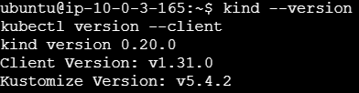

**Step 4: Create a Kubernetes Cluster with kind**

We will create a 3-node Kubernetes cluster using **kind**. This will include one control plane node and two worker nodes.

**4.1. Create the Configuration File**

First, create a configuration file (config.yml) with the following content. We will use **v1.31.0** for the Kubernetes version to match the version of kubectl installed earlier:

kind: Cluster  
apiVersion: kind.x-k8s.io/v1alpha4  
  
nodes:  
- role: control-plane  
 image: kindest/node:v1.31.0 # Match this with kubectl version  
- role: worker  
 image: kindest/node:v1.31.0 # Match this with kubectl version  
- role: worker  
 image: kindest/node:v1.31.0 # Match this with kubectl version

**4.2. Create the Cluster**

Now, use this configuration file to create a 3-node cluster with **kind**:

kind create cluster --config=config.yml

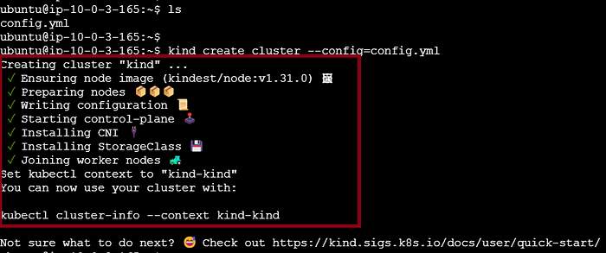

**4.3. Verify the Cluster**

To ensure your Kubernetes cluster is up and running, check the cluster status with the following commands:

kubectl cluster-info  
kubectl get nodes

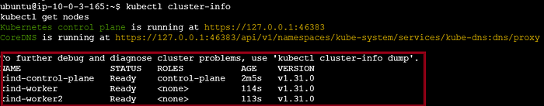

You should see one control-plane node and two worker nodes listed. This confirms that your 3-node Kubernetes cluster is successfully created and ready for deploying applications.

**Step 5: Installing and Configuring Argo CD**

In this step, we will install **Argo CD**, a declarative GitOps continuous delivery tool for Kubernetes.

**5.1. Create an ArgoCD Namespace**

First, create a dedicated namespace for ArgoCD:

kubectl create namespace argocd

**5.2. Install ArgoCD**

Now, install ArgoCD by applying the installation YAML file:

kubectl apply -n argocd -f https://raw.githubusercontent.com/argoproj/argo-cd/stable/manifests/install.yaml

This command will download and install all the necessary resources for Argo CD in your Kubernetes cluster.

After the installation is complete you should see the pods in the argocd namespace:

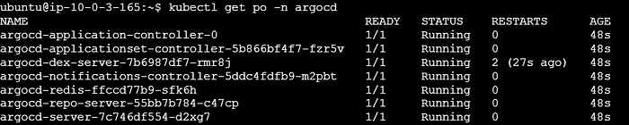

**5.3. Check Argo CD Services**

Verify that the services for Argo CD have been created and are running:

kubectl get svc -n argocd

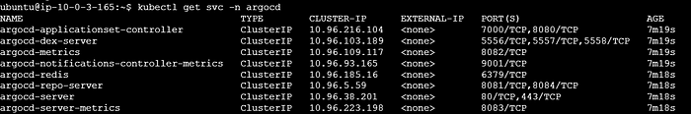

The output will show the services created by Argo CD, including the argocd-server. By default, the argocd-server service will be of type **ClusterIP**, meaning it is accessible only within the Kubernetes cluster.

To make the argocd-server accessible from outside the cluster, we need to change the service type from ClusterIP to NodePort. This will expose the Argo CD server on a port accessible via the external IP of any node in the cluster. We will do this in the next step.

**5.4. Expose the Argo CD Server using NodePort**

Expose the Argo CD server to allow access via a NodePort:

kubectl patch svc argocd-server -n argocd -p '{"spec": {"type": "NodePort"}}'

Now in the below output, you should see the type has changed to NodePort:

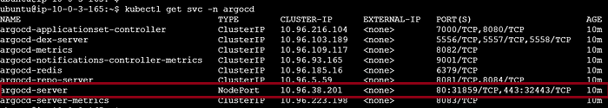

**5.5. Access the Argo CD Server**

Forward the Argo CD server port to your local machine to access the Argo CD UI:

kubectl port-forward --address 0.0.0.0 -n argocd service/argocd-server 8443:443 &

This command forwards the port 8443 on your EC2 instance to port 443 of the Argo CD server. You can now access the Argo CD web interface by navigating to:

https://<EC2_PUBLIC_IP>:8443

**Important**: Ensure that port 8443 is open in your EC2 instance's security group by adding an inbound rule for this port over TCP. This will allow external access to the Argo CD web interface using the public IP address of your EC2 instance.

In the browser, you should the below page:

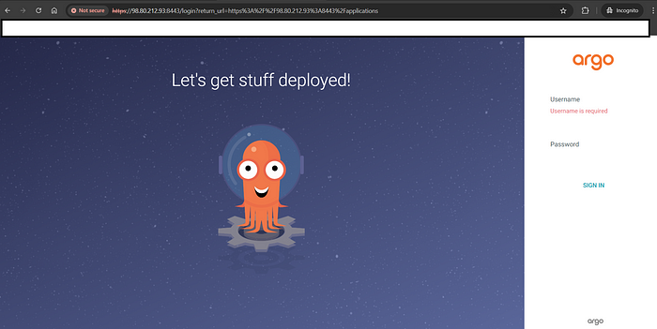

**5.6. Login to ArgoCD**

Retrieve the initial ArgoCD admin password:

kubectl get secret argocd-initial-admin-secret -n argocd -o jsonpath="{.data.password}" | base64 -d

the output of which is as:

kubectl get secret argocd-initial-admin-secret -n argocd -o jsonpath="{.data.password}" | base64 -d  
lYozUklAerSwJaE9

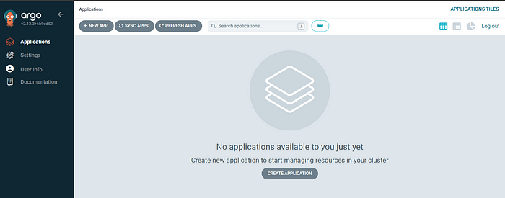

**Step 6: Deploy the Voting App**

**6.1. Create an Argo CD Application**

Next, you’ll create an Argo CD application to deploy the Voting App.

1. In the Argo CD UI, go to **Applications** and click **Create Application**.
2. Fill in the following fields:

* **Application Name**: voting-app
* **Project**: default
* **Sync Policy**: You can either choose manual or automated sync as needed.

3. For the **Source** section, use the following:

* **Repository URL**: [https://github.com/LondheShubham153/k8s-kind-voting-app](https://github.com/LondheShubham153/k8s-kind-voting-app.git)
* **Revision**: main
* **Path**: k8s-specifications

4. For the **Destination** section:

* **Cluster URL**: [https://kubernetes.default.svc](https://kubernetes.default.svc/)
* **Namespace**: default

5. After configuring the application, click **Create**.

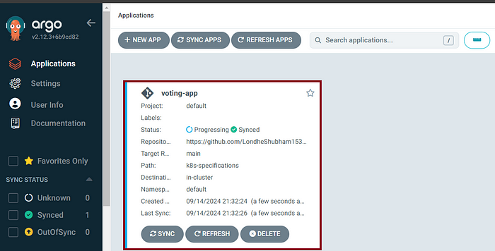

**6.2. Sync the Application**

1. Once the application is created, navigate to the **Applications** section in the Argo CD web UI.
2. You should see the voting-app. Click on it to view the status.
3. Sync the application manually by clicking **Sync**, or configure automated sync for continuous deployment.

Argo CD will now deploy the Voting App to your Kubernetes cluster.

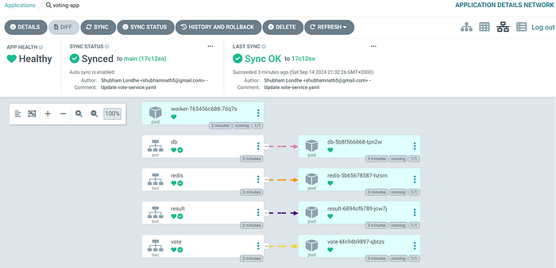

Once you access your cluster and run the command kubectl get po in the default namespace, you should see all the pods for the voting app created and running, similar to this output:

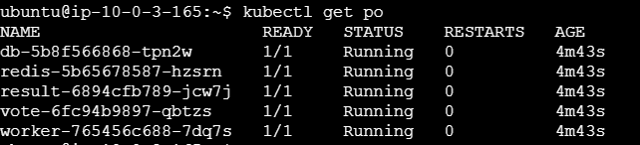

**Step 7: Access the Voting App**

Now that the Voting App is deployed and the pods are running, you can access the application by exposing the services.

**7.1. Verify Services**

First, check that the services for the app have been created:

kubectl get svc

You should see services for the different components of the voting app, such as vote, result, db, redis, and worker. The output will look something like this:

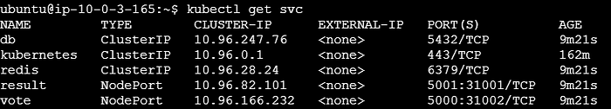

**7.2. Port Forward to Access Services**

To access the application locally, forward the ports for both the vote and result services. Use the --address=0.0.0.0 flag to allow connections from outside localhost:

1. Forward port for the vote service:

kubectl port-forward svc/vote 5000:5000 --address=0.0.0.0 &

2. Forward port for the result service:

kubectl port-forward svc/result 5001:5001 --address=0.0.0.0 &

**7.3. Configure Security Group**

Ensure that your EC2 security group allows inbound traffic on ports 5000 and 5001. You can do this by:

1. Going to the EC2 Management Console.
2. Selecting your instance and noting its security group.
3. Editing the inbound rules of the security group to allow TCP traffic on ports 5000 and 5001.

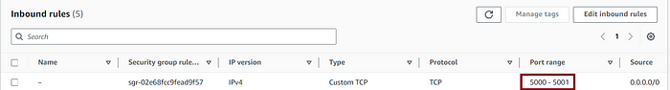

**7.4. Access the Application**

Once port forwarding is set up and the security group is configured, open your browser and access the following URLs:

* Voting UI: http://<EC2-PUBLIC-IP>:5000
* Result UI: http://<EC2-PUBLIC-IP>:5001

You should be able to interact with the Voting App and see the results.

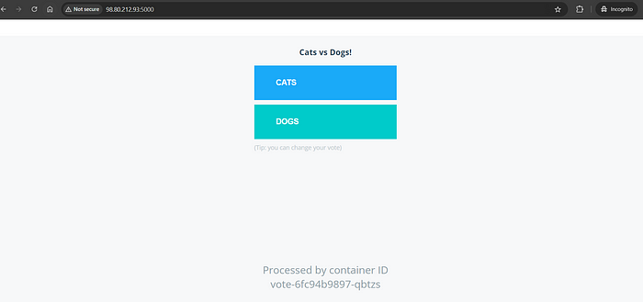

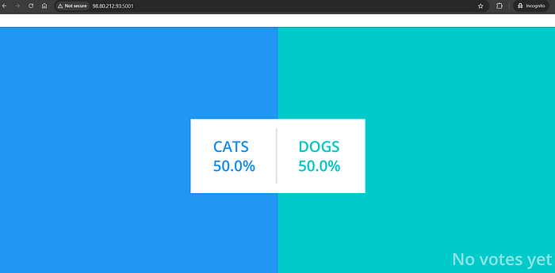

**Step 8: Installing Kubernetes Dashboard**

To manage your Kubernetes cluster more effectively, you can install the Kubernetes Dashboard. Follow these steps to deploy the dashboard and set up access.

**8.1. Deploy Kubernetes Dashboard**

Install the Kubernetes Dashboard by applying the recommended manifest:

kubectl apply -f https://raw.githubusercontent.com/kubernetes/dashboard/v2.7.0/aio/deploy/recommended.yaml

**8.2. Create a Service Account and RBAC**

Before creating a token for dashboard access, you need to create a Service Account and the necessary RBAC (Role-Based Access Control) rules. Apply the following YAML configuration to set up the Service Account and ClusterRoleBinding:

apiVersion: v1  
kind: ServiceAccount  
metadata:  
 name: admin-user  
 namespace: kubernetes-dashboard  
---  
apiVersion: rbac.authorization.k8s.io/v1  
kind: ClusterRoleBinding  
metadata:  
 name: admin-user  
roleRef:  
 apiGroup: rbac.authorization.k8s.io  
 kind: ClusterRole  
 name: cluster-admin  
subjects:  
- kind: ServiceAccount  
 name: admin-user  
 namespace: kubernetes-dashboard

Apply the configuration:

kubectl apply -f <path-to-your-yaml-file>

**8.3. Create a Token for Dashboard Access**

After applying the Service Account and RBAC configuration, create a token for the admin-user:

kubectl -n kubernetes-dashboard create token admin-user

This command will generate a token that you can use to log in to the dashboard.

Output:

kubectl -n kubernetes-dashboard create token admin-user  
eyJhbGciOiJSUzI1NiIsImtpZCI6Ii1JSTFpWHBMaXhQc1NMM0Vmdy1LR3FVbnNPczN6RGQ5dGowRUExRGV6S2cifQ..MBD0WKLphctpx9pSG6TwQUfsGQ8gfGRhXqpEVXcIaDYdge9LPs3gvrSCQb6_b9mPmiJ-BsXnrz1ynT_Ozp8ZzPUt7XX7y8xp0lzfrzeCRLVeJG7htXc3AIerTtUz5zZ7n18mnsxqPjTNFEjCD6EkZYwv4Z0oudNxpuxuXr7v_2Uj_cZfuWvQYsx6zbo7l-wKTsMJP8EM9bbawLi45Q3ttUkW2QO5OqKmiZGFOo5hTSmVFeI0dQARZWE5ZdexEKp4aH68iyXKNB3QnMmYq4Eh5aTybSmSuhm0nvMQm9eq94DFdPNeuuLNreRENgquCmLbK95RGHMrPmN8Gd4065lY2Q

**8.4. Access the Kubernetes Dashboard**

To access the dashboard locally, forward the port for the Kubernetes Dashboard service:

kubectl port-forward -n kubernetes-dashboard svc/kubernetes-dashboard 8080:443 --address=0.0.0.0 &

Open your browser and navigate to:

https://98.80.212.3:8080/

Use the token generated in step 8.3 to log in. You should now have access to the Kubernetes Dashboard and be able to manage your cluster.

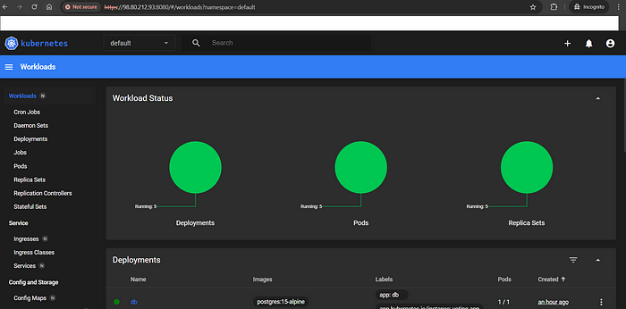

**Summary**

In this blog post, we walked through the process of deploying a Kubernetes-based Voting App on an AWS EC2 instance using Kind and ArgoCD. Here’s a recap of what we accomplished:

1. **Introduction to Kind and ArgoCD**: We introduced Kubernetes in Docker (Kind) for creating local clusters and ArgoCD for continuous deployment.
2. **Prerequisites**: We ensured that we had an AWS account, basic Linux, and Docker knowledge, and outlined the steps to set up an EC2 instance with Ubuntu.
3. **Setting Up EC2**: We created an EC2 instance, configured security groups, and installed Docker and Kind.
4. **Creating a Kubernetes Cluster with Kind**: We created a 3-node Kubernetes cluster using Kind with the appropriate Kubernetes version.
5. **Installing ArgoCD**: We deployed ArgoCD, exposed its service, and configured port forwarding. We also set up the necessary security group rules for external access.
6. **Deploying the Voting App**: We created an ArgoCD application to deploy the Voting App from a GitHub repository, synced the application, and verified that the pods were running correctly.
7. **Accessing the Application**: We configured port forwarding for the vote and result services and updated the EC2 security group to allow traffic on the necessary ports.
8. **Installing Kubernetes Dashboard**: We deployed the Kubernetes Dashboard, set up a Service Account and RBAC, created a token for access, and configured port forwarding for the dashboard.

**Conclusion**

In this blog post, we successfully deployed a Kubernetes-based Voting App on AWS EC2, utilizing Kind for local Kubernetes clusters and ArgoCD for continuous deployment. We also set up the Kubernetes Dashboard for enhanced cluster management.

Special thanks to the [YouTube video by TrainWithShubham](https://www.youtube.com/watch?v=Kbvch_swZWA&t=1504s&ab_channel=TrainWithShubham) for providing valuable guidance and insights that helped shape this tutorial.

Thank you for following along, and happy deploying!

[Kubernetes](https://medium.com/tag/kubernetes?source=post_page-----04c7b92e24b4---------------------------------------)

[Kind Cluster](https://medium.com/tag/kind-cluster?source=post_page-----04c7b92e24b4---------------------------------------)

[DevOps](https://medium.com/tag/devops?source=post_page-----04c7b92e24b4---------------------------------------)

[Deployment](https://medium.com/tag/deployment?source=post_page-----04c7b92e24b4---------------------------------------)

[Argo Cd](https://medium.com/tag/argo-cd?source=post_page-----04c7b92e24b4---------------------------------------)

10

1

[[](https://medium.com/@mudasirhaji?source=post_page---post_author_info--04c7b92e24b4---------------------------------------)](https://medium.com/@mudasirhaji?source=post_page---post_author_info--04c7b92e24b4---------------------------------------)

[Written by Mudasir](https://medium.com/@mudasirhaji?source=post_page---post_author_info--04c7b92e24b4---------------------------------------)

[2.5K Followers](https://medium.com/@mudasirhaji/followers?source=post_page---post_author_info--04c7b92e24b4---------------------------------------)

·[11 Following](https://medium.com/@mudasirhaji/following?source=post_page---post_author_info--04c7b92e24b4---------------------------------------)

AWS Community Builder | DevOps Engineer | 3x AWS | 1x Azure | CCNP | Palo Alto | NSE 3 | Ansible | Terraform | Docker | Jenkins | Git

Following

Responses (1)

Deepanshu

Deepanshu

What are your thoughts?﻿

Cancel

Respond



Also publish to my profile

[[Arun Natarajan](https://medium.com/@iamarunix?source=post_page---post_responses--04c7b92e24b4----0-----------------------------------)](https://medium.com/@iamarunix?source=post_page---post_responses--04c7b92e24b4----0-----------------------------------)

[Arun Natarajan](https://medium.com/@iamarunix?source=post_page---post_responses--04c7b92e24b4----0-----------------------------------)

[Feb 16 (edited)](https://medium.com/@iamarunix/thanks-mudasir-for-the-notes-1e45eaf20b55?source=post_page---post_responses--04c7b92e24b4----0-----------------------------------)

Thanks @mudasir for the notes. Output came like a charm. Better you can add the port 8443 at the starting itself.

1

Reply

More from Mudasir

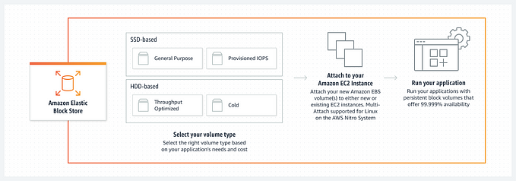

[[Mudasir](https://medium.com/@mudasirhaji?source=post_page---author_recirc--04c7b92e24b4----0---------------------309cb1f3_908c_4d4c_a29f_77646e5d039f--------------)](https://medium.com/@mudasirhaji?source=post_page---author_recirc--04c7b92e24b4----0---------------------309cb1f3_908c_4d4c_a29f_77646e5d039f--------------)

[Mudasir](https://medium.com/@mudasirhaji?source=post_page---author_recirc--04c7b92e24b4----0---------------------309cb1f3_908c_4d4c_a29f_77646e5d039f--------------)

**[Step by Step process of how to add and mount EBS Volume on Ubuntu EC2 Linux Instance](https://medium.com/@mudasirhaji/step-by-step-process-of-how-to-add-and-mount-ebs-volume-on-ubuntu-ec2-linux-instance-a4be8870a4dd?source=post_page---author_recirc--04c7b92e24b4----0---------------------309cb1f3_908c_4d4c_a29f_77646e5d039f--------------)**

[Introduction:](https://medium.com/@mudasirhaji/step-by-step-process-of-how-to-add-and-mount-ebs-volume-on-ubuntu-ec2-linux-instance-a4be8870a4dd?source=post_page---author_recirc--04c7b92e24b4----0---------------------309cb1f3_908c_4d4c_a29f_77646e5d039f--------------)

Nov 24, 2023

[271](https://medium.com/@mudasirhaji/step-by-step-process-of-how-to-add-and-mount-ebs-volume-on-ubuntu-ec2-linux-instance-a4be8870a4dd?source=post_page---author_recirc--04c7b92e24b4----0---------------------309cb1f3_908c_4d4c_a29f_77646e5d039f--------------)

[4](https://medium.com/@mudasirhaji/step-by-step-process-of-how-to-add-and-mount-ebs-volume-on-ubuntu-ec2-linux-instance-a4be8870a4dd?source=post_page---author_recirc--04c7b92e24b4----0---------------------309cb1f3_908c_4d4c_a29f_77646e5d039f--------------)

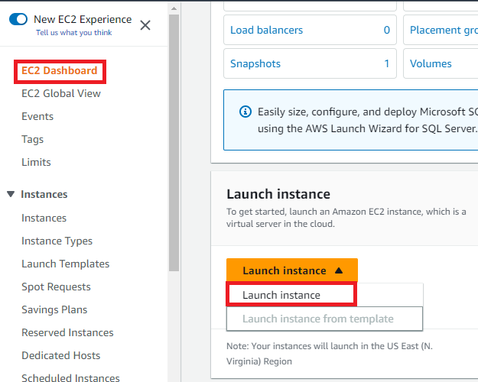

[[Mudasir](https://medium.com/@mudasirhaji?source=post_page---author_recirc--04c7b92e24b4----1---------------------309cb1f3_908c_4d4c_a29f_77646e5d039f--------------)](https://medium.com/@mudasirhaji?source=post_page---author_recirc--04c7b92e24b4----1---------------------309cb1f3_908c_4d4c_a29f_77646e5d039f--------------)

[Mudasir](https://medium.com/@mudasirhaji?source=post_page---author_recirc--04c7b92e24b4----1---------------------309cb1f3_908c_4d4c_a29f_77646e5d039f--------------)

**[Complete Step-by-Step Jenkins CICD with GitHub Integration](https://medium.com/@mudasirhaji/complete-step-by-step-jenkins-cicd-with-github-integration-aae3961b6e33?source=post_page---author_recirc--04c7b92e24b4----1---------------------309cb1f3_908c_4d4c_a29f_77646e5d039f--------------)**

[In this blog, we will deploy a node.js application on an EC2 instance and we will create a CICD pipeline using Jenkins.](https://medium.com/@mudasirhaji/complete-step-by-step-jenkins-cicd-with-github-integration-aae3961b6e33?source=post_page---author_recirc--04c7b92e24b4----1---------------------309cb1f3_908c_4d4c_a29f_77646e5d039f--------------)

Apr 4, 2023

[326](https://medium.com/@mudasirhaji/complete-step-by-step-jenkins-cicd-with-github-integration-aae3961b6e33?source=post_page---author_recirc--04c7b92e24b4----1---------------------309cb1f3_908c_4d4c_a29f_77646e5d039f--------------)

[2](https://medium.com/@mudasirhaji/complete-step-by-step-jenkins-cicd-with-github-integration-aae3961b6e33?source=post_page---author_recirc--04c7b92e24b4----1---------------------309cb1f3_908c_4d4c_a29f_77646e5d039f--------------)

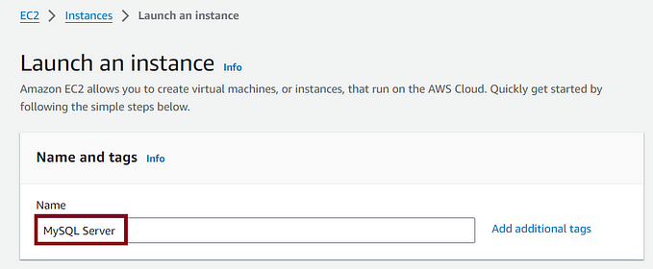

[[Mudasir](https://medium.com/@mudasirhaji?source=post_page---author_recirc--04c7b92e24b4----2---------------------309cb1f3_908c_4d4c_a29f_77646e5d039f--------------)](https://medium.com/@mudasirhaji?source=post_page---author_recirc--04c7b92e24b4----2---------------------309cb1f3_908c_4d4c_a29f_77646e5d039f--------------)

[Mudasir](https://medium.com/@mudasirhaji?source=post_page---author_recirc--04c7b92e24b4----2---------------------309cb1f3_908c_4d4c_a29f_77646e5d039f--------------)

**[Step-by-step guide on how to install MySQL 8 server on AWS EC2Linux 2 in 2024](https://medium.com/@mudasirhaji/step-by-step-guide-on-how-to-install-mysql-8-server-on-aws-ec2linux-2-in-2024-72f3f14764b6?source=post_page---author_recirc--04c7b92e24b4----2---------------------309cb1f3_908c_4d4c_a29f_77646e5d039f--------------)**

[Introduction](https://medium.com/@mudasirhaji/step-by-step-guide-on-how-to-install-mysql-8-server-on-aws-ec2linux-2-in-2024-72f3f14764b6?source=post_page---author_recirc--04c7b92e24b4----2---------------------309cb1f3_908c_4d4c_a29f_77646e5d039f--------------)

Aug 11, 2024

[73](https://medium.com/@mudasirhaji/step-by-step-guide-on-how-to-install-mysql-8-server-on-aws-ec2linux-2-in-2024-72f3f14764b6?source=post_page---author_recirc--04c7b92e24b4----2---------------------309cb1f3_908c_4d4c_a29f_77646e5d039f--------------)

[1](https://medium.com/@mudasirhaji/step-by-step-guide-on-how-to-install-mysql-8-server-on-aws-ec2linux-2-in-2024-72f3f14764b6?source=post_page---author_recirc--04c7b92e24b4----2---------------------309cb1f3_908c_4d4c_a29f_77646e5d039f--------------)

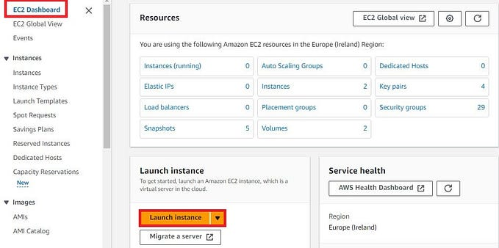

[[Mudasir](https://medium.com/@mudasirhaji?source=post_page---author_recirc--04c7b92e24b4----3---------------------309cb1f3_908c_4d4c_a29f_77646e5d039f--------------)](https://medium.com/@mudasirhaji?source=post_page---author_recirc--04c7b92e24b4----3---------------------309cb1f3_908c_4d4c_a29f_77646e5d039f--------------)

[Mudasir](https://medium.com/@mudasirhaji?source=post_page---author_recirc--04c7b92e24b4----3---------------------309cb1f3_908c_4d4c_a29f_77646e5d039f--------------)

**[A Step-by-Step Guide to Installing Docker on Windows Server 2022 on AWS EC2](https://medium.com/@mudasirhaji/a-step-by-step-guide-to-installing-docker-on-windows-server-2022-on-aws-ec2-d5e9191dc55e?source=post_page---author_recirc--04c7b92e24b4----3---------------------309cb1f3_908c_4d4c_a29f_77646e5d039f--------------)**

[Introduction:](https://medium.com/@mudasirhaji/a-step-by-step-guide-to-installing-docker-on-windows-server-2022-on-aws-ec2-d5e9191dc55e?source=post_page---author_recirc--04c7b92e24b4----3---------------------309cb1f3_908c_4d4c_a29f_77646e5d039f--------------)

Nov 11, 2023

[34](https://medium.com/@mudasirhaji/a-step-by-step-guide-to-installing-docker-on-windows-server-2022-on-aws-ec2-d5e9191dc55e?source=post_page---author_recirc--04c7b92e24b4----3---------------------309cb1f3_908c_4d4c_a29f_77646e5d039f--------------)

[5](https://medium.com/@mudasirhaji/a-step-by-step-guide-to-installing-docker-on-windows-server-2022-on-aws-ec2-d5e9191dc55e?source=post_page---author_recirc--04c7b92e24b4----3---------------------309cb1f3_908c_4d4c_a29f_77646e5d039f--------------)

[See all from Mudasir](https://medium.com/@mudasirhaji?source=post_page---author_recirc--04c7b92e24b4---------------------------------------)

Recommended from Medium

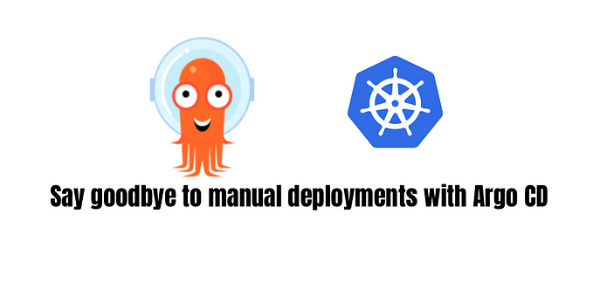

[[DataDrivenInvestor](https://medium.com/datadriveninvestor?source=post_page---read_next_recirc--04c7b92e24b4----0---------------------cab7e361_9e1f_4bb0_99c7_562e8e5e963f--------------)](https://medium.com/datadriveninvestor?source=post_page---read_next_recirc--04c7b92e24b4----0---------------------cab7e361_9e1f_4bb0_99c7_562e8e5e963f--------------)

In

[DataDrivenInvestor](https://medium.com/datadriveninvestor?source=post_page---read_next_recirc--04c7b92e24b4----0---------------------cab7e361_9e1f_4bb0_99c7_562e8e5e963f--------------)

by

[Aleksei Aleinikov](https://medium.com/@aleksei.aleinikov.gr?source=post_page---read_next_recirc--04c7b92e24b4----0---------------------cab7e361_9e1f_4bb0_99c7_562e8e5e963f--------------)

**[GitOps & Argo CD in 2025: Simplifying Kubernetes Deployments with Automation](https://medium.com/datadriveninvestor/gitops-argo-cd-in-2025-simplifying-kubernetes-deployments-with-automation-5ed771b96085?source=post_page---read_next_recirc--04c7b92e24b4----0---------------------cab7e361_9e1f_4bb0_99c7_562e8e5e963f--------------)**

[Right now, we have GitLab in place but haven’t fully embraced GitOps. In other words, while Git helps us track code versions, we don’t yet…](https://medium.com/datadriveninvestor/gitops-argo-cd-in-2025-simplifying-kubernetes-deployments-with-automation-5ed771b96085?source=post_page---read_next_recirc--04c7b92e24b4----0---------------------cab7e361_9e1f_4bb0_99c7_562e8e5e963f--------------)

Feb 27

[26](https://medium.com/datadriveninvestor/gitops-argo-cd-in-2025-simplifying-kubernetes-deployments-with-automation-5ed771b96085?source=post_page---read_next_recirc--04c7b92e24b4----0---------------------cab7e361_9e1f_4bb0_99c7_562e8e5e963f--------------)

[1](https://medium.com/datadriveninvestor/gitops-argo-cd-in-2025-simplifying-kubernetes-deployments-with-automation-5ed771b96085?source=post_page---read_next_recirc--04c7b92e24b4----0---------------------cab7e361_9e1f_4bb0_99c7_562e8e5e963f--------------)

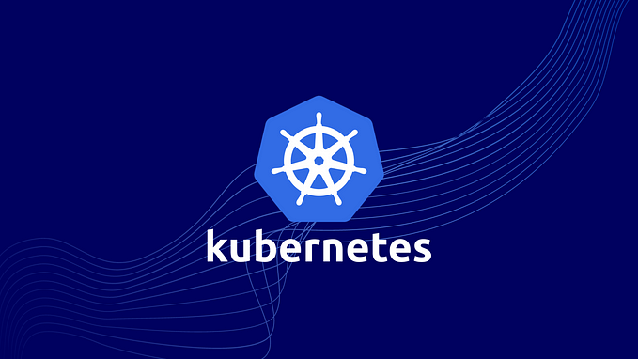

[[Harshit Sharma](https://medium.com/@harshit1470?source=post_page---read_next_recirc--04c7b92e24b4----1---------------------cab7e361_9e1f_4bb0_99c7_562e8e5e963f--------------)](https://medium.com/@harshit1470?source=post_page---read_next_recirc--04c7b92e24b4----1---------------------cab7e361_9e1f_4bb0_99c7_562e8e5e963f--------------)

[Harshit Sharma](https://medium.com/@harshit1470?source=post_page---read_next_recirc--04c7b92e24b4----1---------------------cab7e361_9e1f_4bb0_99c7_562e8e5e963f--------------)

**[Top Kubernetes Commands Every DevOps Engineer Should Know](https://medium.com/@harshit1470/top-kubernetes-commands-every-devops-engineer-should-know-6abf09d0db8f?source=post_page---read_next_recirc--04c7b92e24b4----1---------------------cab7e361_9e1f_4bb0_99c7_562e8e5e963f--------------)**

[A Practical Guide to Essential Kubernetes Commands for DevOps Engineers](https://medium.com/@harshit1470/top-kubernetes-commands-every-devops-engineer-should-know-6abf09d0db8f?source=post_page---read_next_recirc--04c7b92e24b4----1---------------------cab7e361_9e1f_4bb0_99c7_562e8e5e963f--------------)

Nov 28, 2024

[41](https://medium.com/@harshit1470/top-kubernetes-commands-every-devops-engineer-should-know-6abf09d0db8f?source=post_page---read_next_recirc--04c7b92e24b4----1---------------------cab7e361_9e1f_4bb0_99c7_562e8e5e963f--------------)

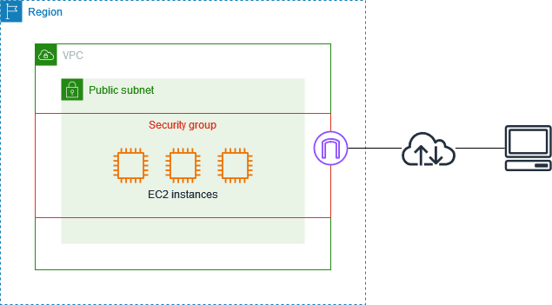

[[AWS Tip](https://medium.com/aws-tip?source=post_page---read_next_recirc--04c7b92e24b4----0---------------------cab7e361_9e1f_4bb0_99c7_562e8e5e963f--------------)](https://medium.com/aws-tip?source=post_page---read_next_recirc--04c7b92e24b4----0---------------------cab7e361_9e1f_4bb0_99c7_562e8e5e963f--------------)

In

[AWS Tip](https://medium.com/aws-tip?source=post_page---read_next_recirc--04c7b92e24b4----0---------------------cab7e361_9e1f_4bb0_99c7_562e8e5e963f--------------)

by

[Nagarjun (Arjun) Nagesh](https://medium.com/@nagarjun_nagesh?source=post_page---read_next_recirc--04c7b92e24b4----0---------------------cab7e361_9e1f_4bb0_99c7_562e8e5e963f--------------)

**[Security Best Practices for Security Groups in AWS](https://medium.com/aws-tip/security-best-practices-for-security-groups-in-aws-66b548832335?source=post_page---read_next_recirc--04c7b92e24b4----0---------------------cab7e361_9e1f_4bb0_99c7_562e8e5e963f--------------)**

[Should You Ever Put an EC2 Instance in a Public Subnet?](https://medium.com/aws-tip/security-best-practices-for-security-groups-in-aws-66b548832335?source=post_page---read_next_recirc--04c7b92e24b4----0---------------------cab7e361_9e1f_4bb0_99c7_562e8e5e963f--------------)

Feb 21

[20](https://medium.com/aws-tip/security-best-practices-for-security-groups-in-aws-66b548832335?source=post_page---read_next_recirc--04c7b92e24b4----0---------------------cab7e361_9e1f_4bb0_99c7_562e8e5e963f--------------)



[[Aidudo Nicholas](https://medium.com/@godwinjulin?source=post_page---read_next_recirc--04c7b92e24b4----1---------------------cab7e361_9e1f_4bb0_99c7_562e8e5e963f--------------)](https://medium.com/@godwinjulin?source=post_page---read_next_recirc--04c7b92e24b4----1---------------------cab7e361_9e1f_4bb0_99c7_562e8e5e963f--------------)

[Aidudo Nicholas](https://medium.com/@godwinjulin?source=post_page---read_next_recirc--04c7b92e24b4----1---------------------cab7e361_9e1f_4bb0_99c7_562e8e5e963f--------------)

**[Optimizing VM Preparation for Application Deployment with Ansible Tower](https://medium.com/@godwinjulin/optimizing-vm-preparation-for-application-deployment-with-ansible-tower-229eaa29f676?source=post_page---read_next_recirc--04c7b92e24b4----1---------------------cab7e361_9e1f_4bb0_99c7_562e8e5e963f--------------)**

[# Running Server Assurance to Prepare VMs for Applications with Ansible Tower](https://medium.com/@godwinjulin/optimizing-vm-preparation-for-application-deployment-with-ansible-tower-229eaa29f676?source=post_page---read_next_recirc--04c7b92e24b4----1---------------------cab7e361_9e1f_4bb0_99c7_562e8e5e963f--------------)

Oct 30, 2024

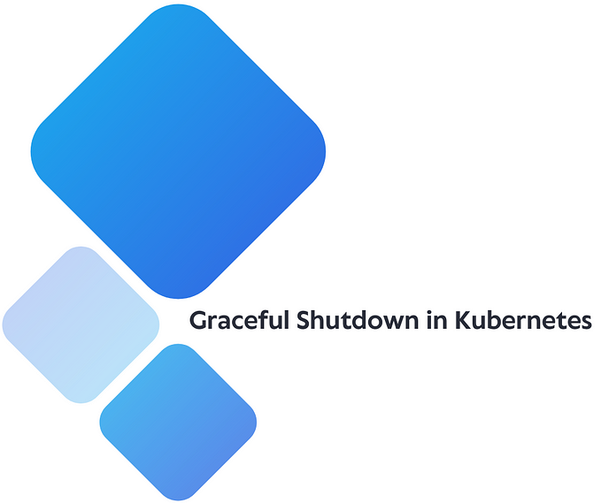

[[Ömer Naci Soydemir](https://medium.com/@omernaci?source=post_page---read_next_recirc--04c7b92e24b4----2---------------------cab7e361_9e1f_4bb0_99c7_562e8e5e963f--------------)](https://medium.com/@omernaci?source=post_page---read_next_recirc--04c7b92e24b4----2---------------------cab7e361_9e1f_4bb0_99c7_562e8e5e963f--------------)

[Ömer Naci Soydemir](https://medium.com/@omernaci?source=post_page---read_next_recirc--04c7b92e24b4----2---------------------cab7e361_9e1f_4bb0_99c7_562e8e5e963f--------------)

**[Graceful shutdown in Kubernetes](https://medium.com/@omernaci/graceful-shutdown-in-kubernetes-bd91d247da80?source=post_page---read_next_recirc--04c7b92e24b4----2---------------------cab7e361_9e1f_4bb0_99c7_562e8e5e963f--------------)**

[In this article, you will learn how to prevent broken connections when a pod starts or shuts down. You will also learn how to shut down…](https://medium.com/@omernaci/graceful-shutdown-in-kubernetes-bd91d247da80?source=post_page---read_next_recirc--04c7b92e24b4----2---------------------cab7e361_9e1f_4bb0_99c7_562e8e5e963f--------------)

Nov 9, 2024

[41](https://medium.com/@omernaci/graceful-shutdown-in-kubernetes-bd91d247da80?source=post_page---read_next_recirc--04c7b92e24b4----2---------------------cab7e361_9e1f_4bb0_99c7_562e8e5e963f--------------)

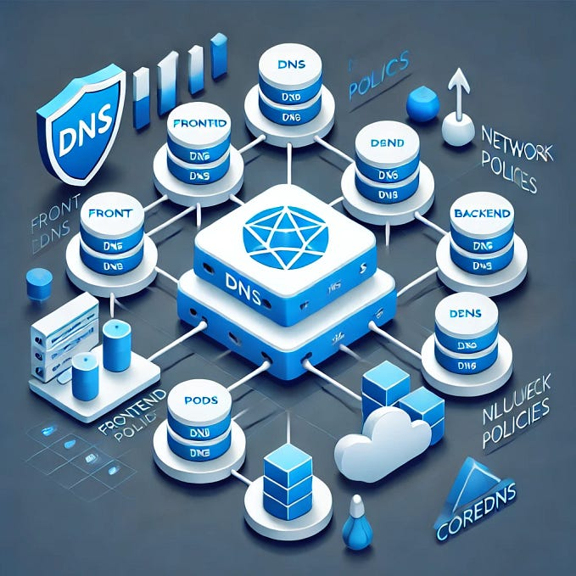

[[jay75chauhan](https://medium.com/@jay75chauhan?source=post_page---read_next_recirc--04c7b92e24b4----3---------------------cab7e361_9e1f_4bb0_99c7_562e8e5e963f--------------)](https://medium.com/@jay75chauhan?source=post_page---read_next_recirc--04c7b92e24b4----3---------------------cab7e361_9e1f_4bb0_99c7_562e8e5e963f--------------)

[jay75chauhan](https://medium.com/@jay75chauhan?source=post_page---read_next_recirc--04c7b92e24b4----3---------------------cab7e361_9e1f_4bb0_99c7_562e8e5e963f--------------)

**[Kubernetes DNS and Network Policies: Secure Service Communication in Your Cluster](https://medium.com/@jay75chauhan/kubernetes-dns-and-network-policies-secure-service-communication-in-your-cluster-1ee2e378f7a6?source=post_page---read_next_recirc--04c7b92e24b4----3---------------------cab7e361_9e1f_4bb0_99c7_562e8e5e963f--------------)**

[Kubernetes, the go-to platform for orchestrating containerized applications, simplifies pod and service communication through an essential…](https://medium.com/@jay75chauhan/kubernetes-dns-and-network-policies-secure-service-communication-in-your-cluster-1ee2e378f7a6?source=post_page---read_next_recirc--04c7b92e24b4----3---------------------cab7e361_9e1f_4bb0_99c7_562e8e5e963f--------------)

Oct 24, 2024

[See more recommendations](https://medium.com/?source=post_page---read_next_recirc--04c7b92e24b4---------------------------------------)

[Help](https://help.medium.com/hc/en-us?source=post_page-----04c7b92e24b4---------------------------------------)

[Status](https://medium.statuspage.io/?source=post_page-----04c7b92e24b4---------------------------------------)

[About](https://medium.com/about?autoplay=1&source=post_page-----04c7b92e24b4---------------------------------------)

[Careers](https://medium.com/jobs-at-medium/work-at-medium-959d1a85284e?source=post_page-----04c7b92e24b4---------------------------------------)

[Press](mailto:pressinquiries@medium.com)

[Blog](https://blog.medium.com/?source=post_page-----04c7b92e24b4---------------------------------------)

[Privacy](https://policy.medium.com/medium-privacy-policy-f03bf92035c9?source=post_page-----04c7b92e24b4---------------------------------------)

[Terms](https://policy.medium.com/medium-terms-of-service-9db0094a1e0f?source=post_page-----04c7b92e24b4---------------------------------------)

[Text to speech](https://speechify.com/medium?source=post_page-----04c7b92e24b4---------------------------------------)

[Teams](https://medium.com/business?source=post_page-----04c7b92e24b4---------------------------------------)